**GDD & TDD**

**Game Concept**

A horde wave survival game where you unlock more rooms as you slay more enemies, no actual coding implemented, only level design.

**Setting**

A Sci-fi underground facility containing living quarters, canteen, medical ward and research laboratories. The facility was recently abandoned due to a breach leaving various broken machinery behind, tons of trash and monster remain. It has only just been abandoned meaning all models are still new and do not possess any moss, mould or rust.

**Story**

A sci-fi Scientific Laboratory in the arctic that has experienced a breach from their experiment that was encased in Ice, causing unprecedented amounts of damage and chaos, and has recently been abandoned by all researchers, the bodies where not retrievable after the event but now, the bodies are nowhere to be seen.

**Research**

For research, I looked to a game called Viscera Cleanup Detail which is about a janitor company cleaning up after various breaches of containment in various Sci-fi laboratories, cleaning up dead bodies, sealing up bullet holes and replenishing/repairing various broken stuff found around the facility.

1-6: Medical examination ward for Alien Entities to study them

7-8: Lobby Area containing scanners and mounted turrets for defences

9-10: Armoury containing multiple mechs in case of a breach

11-13: Lounge Areas and Corridors

14-16: Office Cubicles and Reception

17-18: Staircase leading to basement

19: Ceiling for lighting and texture inspiration

20: Underground Office

21-23: Corridors with props

24-26: Cells for the Alien Entities

27: Wall Texture

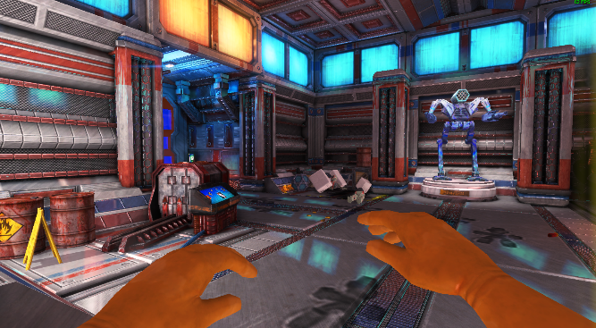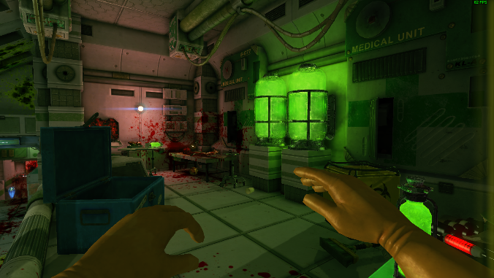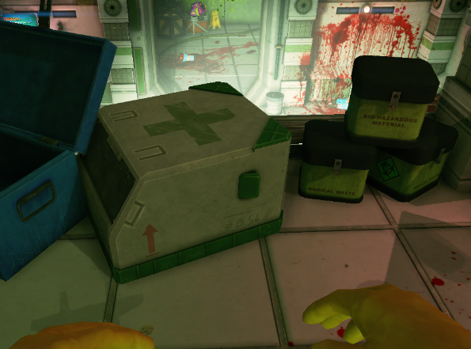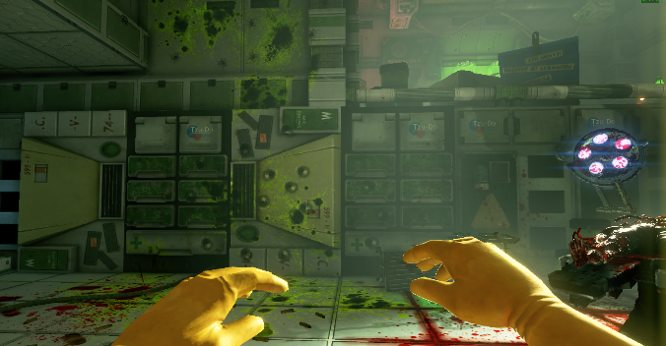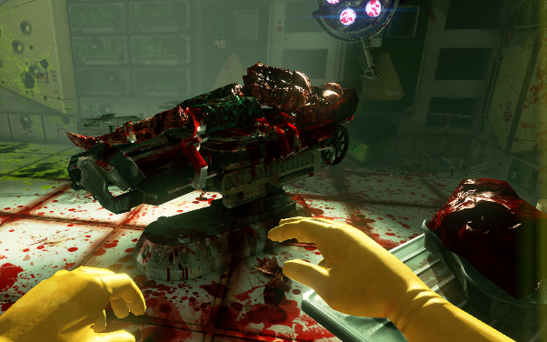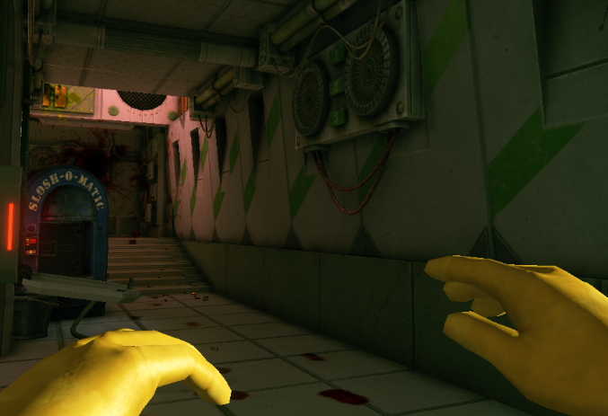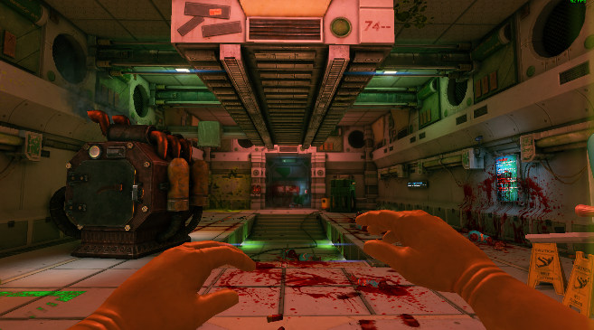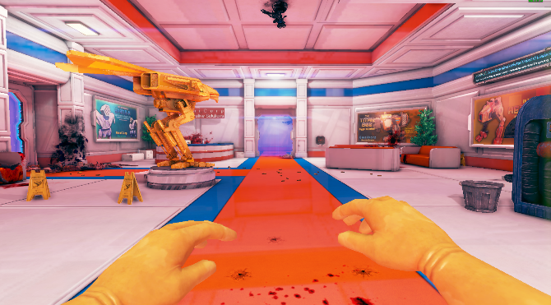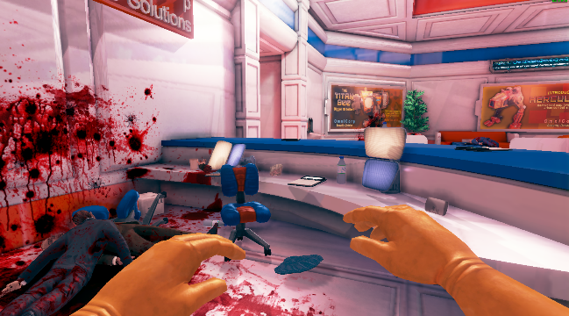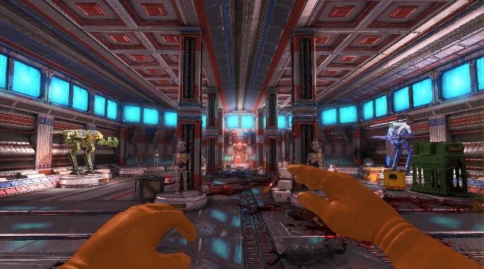

8

7

10

9

1

2

3

4

5

6

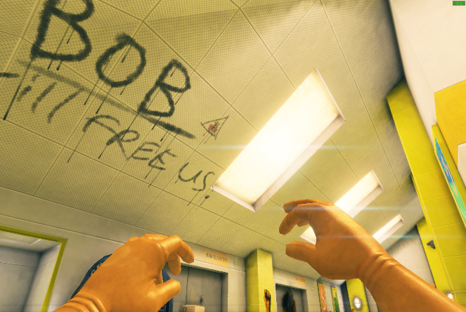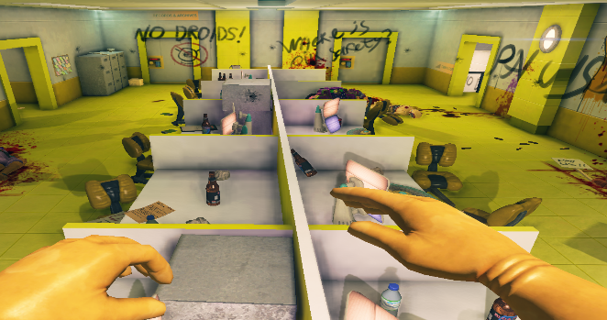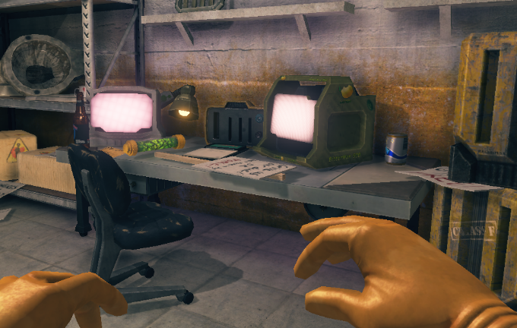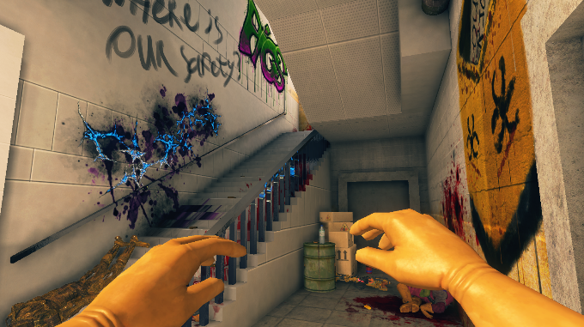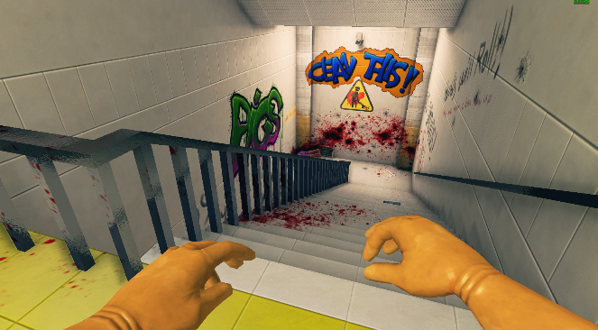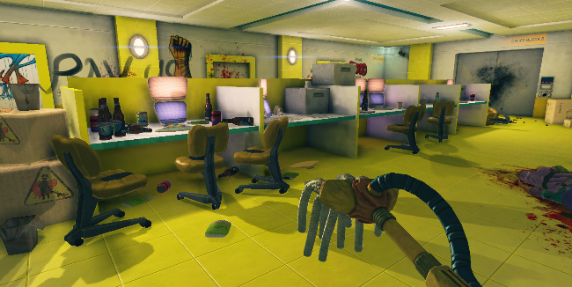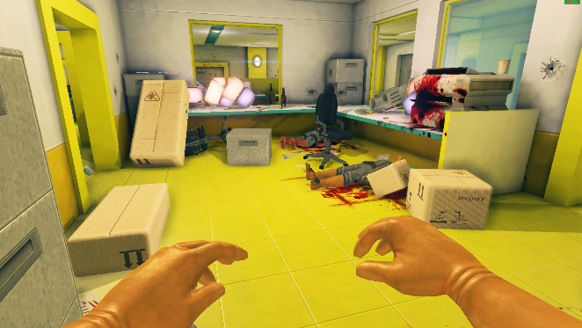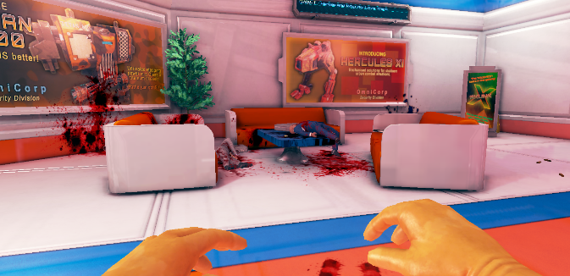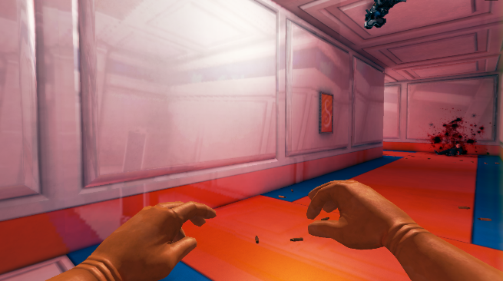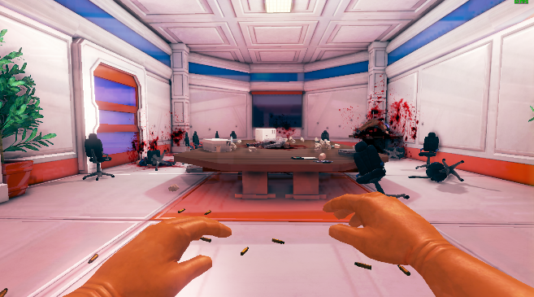

20

19

18

17

16

15

14

13

12

11

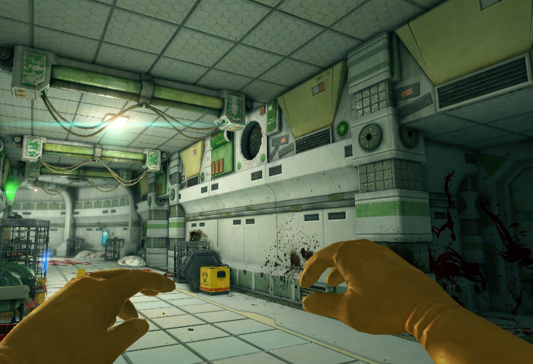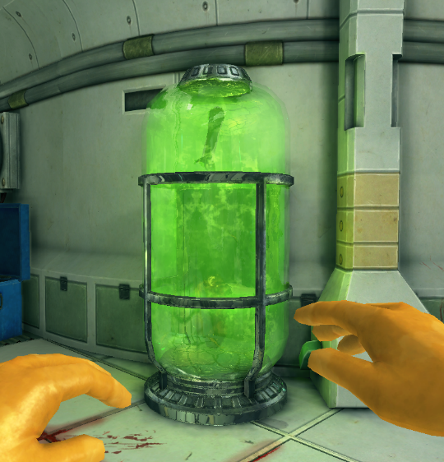

21

22

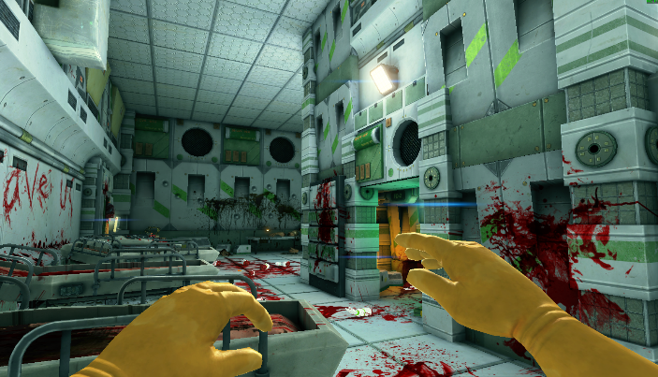

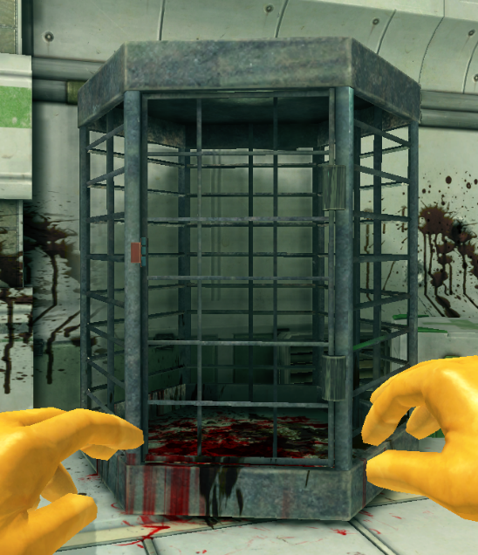

23

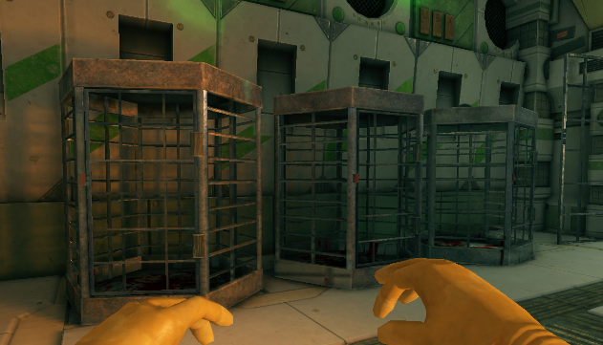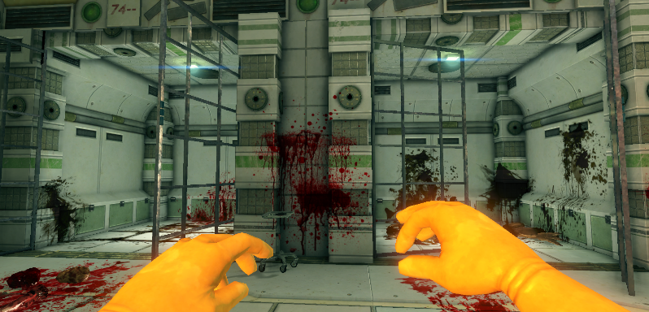

25

24

26

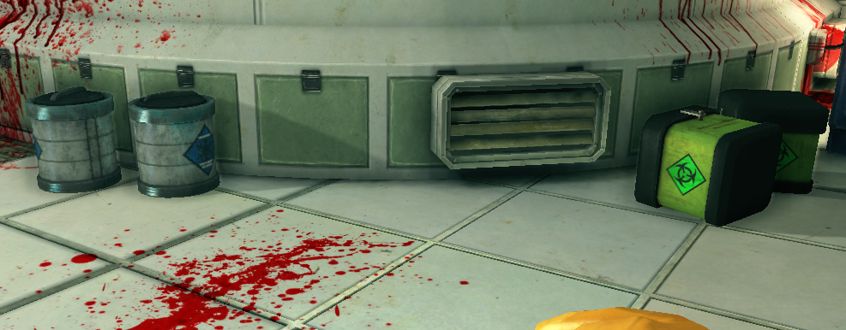

27

**Software Used**

Blender – 3D modelling, lighting, particles, animation and scene building

Aseprite – Creating Textures and Animated Textures

**Level Design**

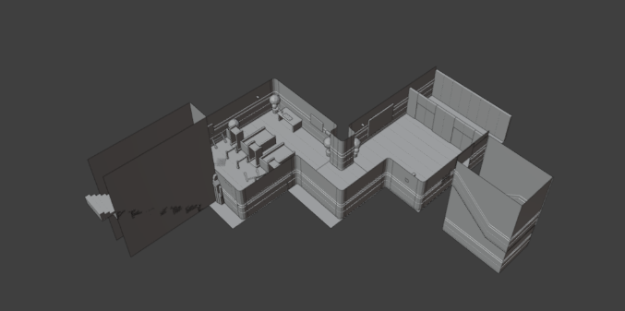

Entrance Security leading to lower floor.

A safe zone area meant to show the player how to the play the game by explaining the buttons and having the player fight a restrained monster to see what they are up against.

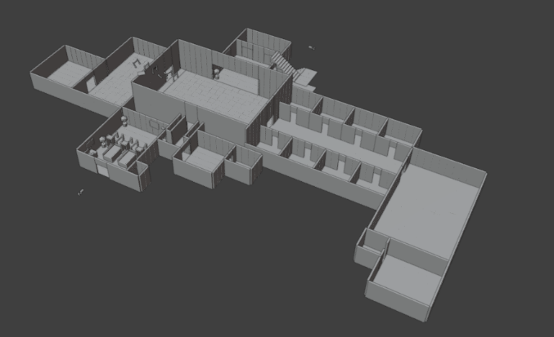

Main part of the Laboratory, containing all facilities required for a live-able habitat.

This floor will be the first floor the player will explore through; they must unlock all rooms before they can access the bottom floor.

Floor needs redesigning, it is currently too linear.

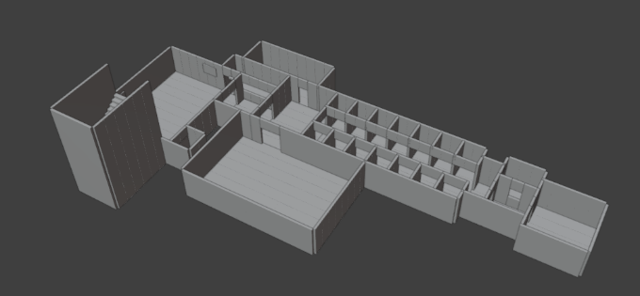

Bottom floor containing the holding cells for the experiments and all research equipment.

This floor contains the beginning point of the breach that occurred which caused all the chaos

Floor needs redesigning, it is currently too linear.

**Modelling**

The modelling style I’m going for this project is Low Poly due to the large amount of modelling that is required for me to completely furnish and decorate the scene. All the models are made from primitive objects being shaped differently and contain little to no extrusions to keep that low poly style while also making it easier to UV unwrap them for texturing. It also mixes well with the Art Style I am aiming for as it goes well with Pixel Art.

**Art Style**

The Art Style for the scene is Pixel Art, I manually create the textures using Aseprite. I also manually create the Height map, Roughness map, Emissive map and Normal map to make 2D faces look 3D, this is done to make the scene contain way less vertices and be way more optimised for a potential game. Hand Drawing all the texture also allows me to create as many unique materials I want and is incredibly easy to create Trim Sheets for many of the materials as each trim is only a few hundred pixels total.

**VFX**

For the Lighting, Particles and Animations, I will be fully utilising Blender’s tools as it allows me to quickly create dynamic scenes while also avoiding making objects too repetitive. For lighting, I will also add Negative lighting to create shadows in any locations I deem fit. For Particles, I can use hair modifiers on the various flora found around the scene with a different seed value to prevent any repetitiveness between props. For Animation, I can animate various objects with unique animations between them even if they are the same object to avoid repetition, I will also create 2D animations using Aseprite for monitors and other electrical appliances found around the map to make it livelier.

**Bibliography**

[Viscera Cleanup Detail Steam Store Link](https://store.steampowered.com/app/246900/Viscera_Cleanup_Detail/)

***Prototype Description Below***

**Prototype Description**

**Project Overview**

The project is a 3D Sci-fi Scientific Laboratory level inside Blender with all the textures created by hand on Aseprite. The level will contain 3 different floors; the top floor will be the tutorial area showcasing the controls and have a constrained enemy to show the player what they will have to go up against. The 2nd floor will contain all the facilities you would expect an actual laboratory to require becoming a live-able habitat for the researchers. It will be the floor that is connected to the research facilities found on the 3rd floor which also contain various security checkpoints and the holding cells of various experiments that had escaped in the breach.

**Core Features**

The prototype will contain a Semi-Complete First Floor that will showcase how the rest of the scene will look like. Currently reworking all textures as the current ones are not working properly.

The First Floor will not contain any trash or broken props yet as I have not made any variations of models, which will come later in development, it will currently only possess the main props you’d expect to find in the location with some ink blotches scattered around. The lighting will be mostly complete with a mild use of particles and little to no animation.

**Limitations & Future Development**

The biggest issue I’ve encountered was the texture normal not working correctly, after consulting with my supervisor, I had learned my Normal Maps did not contain enough pixels to make the Normal Maps to work as expected. To fix this, I created a new texture file on Aseprite and duplicate the Colour, Height, Roughness and Emissive maps but 2 to 4 times the original size, without increasing the detail of the texture, meaning each pixel will be a 2x2, 3x3 or a 4x4. The only texture that gets increased resolution is the Normal Map to make it work as intended.

I have also concluded that the level needs redesigning as it is currently too linear with too many single entrances in various rooms, making it extremely hard for the player to navigate. While the level makes sense in a realistic point of view, it does not work well for a game. As such I will redesign the 2nd and 3rd floor to contain more loops and multiple entrances to various rooms.

The final issue I have encountered is how time consuming it is to create the textures for each prop, to solve this issue, I will create a new texture that contains just the colours in the colour palette I am using but with various Roughness maps on each colour. This will allow me to quickly make a flat solid colour be exactly as Shiny or Rough as I want it to be without wasting lots of time on small props.